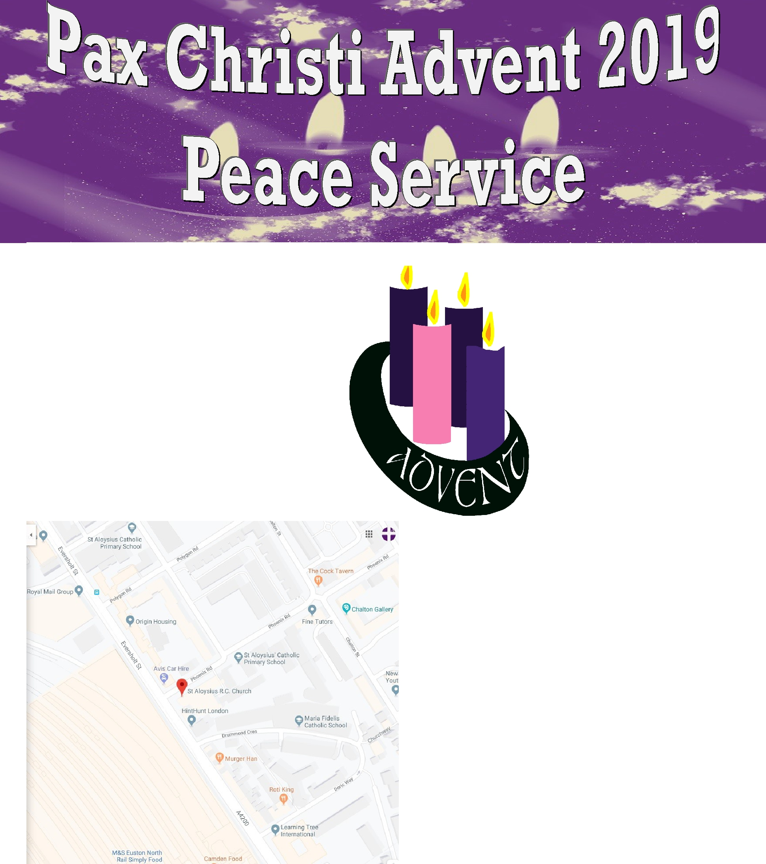

Monday 9 December
@ 7.00pm

St Aloysius Church
20 Phoenix Road Euston
London NW1 1TA

All are welcome!

Music led by Julie McCann

Rehearsal for singers and musicians on Saturday 7th December 2-4pm
Contact office for details

The service will be followed by our alternative Christmas market in Maria Fidelis school
Gifts from Jesuit Refugee Service, Traidcraft, Palestinian (Zaytoun) goods, books, cards and much more.

Mulled wine and mince pies too.


PAX CHRISTI

St Joseph’s, Watford Way, London NW4 4TY www.paxchristi.org.uk

https://twitter.com/paxchristiuk

0208 203 4884

